Unit Plan:
Right Triangles & the Pythagorean Theorem

Incorporating ELL Strategies into
Math Content Area Teaching

C. Sage Forbes-Gray
Spring 2011
Dr. Bearse

Table of Contents:
Introduction/Bibliography pages 3-7

Background Knowledge:
- Triangle Web page 8
- Compare Contrast page 9-10

Vocabulary:
- Concept Ladder page 11
- What is it? page 12-13

Pre-reading:
- Anticipation Guide page 14-15
- Two or Three Things I Know for Sure page 16-17

While reading:
- Bookmark page 18-19
- Get the Gist page 20
- Collaborative Poster page 21

After Reading:
- 3, 2, 1 page 22
- Hollywood Squares page 23

Rubrics page 24-28

Reflection page 29-30

Action Plan page 31

Semester Work page 32-end

Introduction: Right Triangles and the Pythagorean Theorem Unit Sage Forbes-Gray
Coming up in April, our school’s 7th grade pacing calendar states that we will be exploring right triangles, including the Pythagorean Theorem. My middle school, located in Sunset Park, Brooklyn, is predominantly populated with students from the Dominican Republic, Puerto Rico, Mexico, China and Yemen. Over half of our students receive services as designated English Language Learners (ELLs), and closer to 90% have at some point in their lives received ELL services. Despite this fact, our school is just beginning to really consider the unique needs of ELLs when establishing curricula, planning lessons and carrying out instruction. In an effort to speed along this process for myself, I decided to start studying TESOL at Touro College in hopes of acquiring meaningful ELL strategies to support my students.
The Right Triangles and Pythagorean Theorem unit is one of the few brand new topics in the 7th grade curriculum. That doesn’t mean the whole year is a review. For instance, they learn how to calculate tax and tip, although it is really just applied decimal multiplication, a topic from before 7th grade. In this unit, students learn for the first time that there is a relationship between the sides of a right triangle. They organically ask of themselves: what is the relationship between the sides of a right triangle? In order to understand the relationship between the sides of a triangle, the students must first know how to name a right triangle and recognize it as a unique figure, different from other triangles. Students will ask first: what is a right triangle and what language do I use to describe it?
It is essential to build on prior knowledge from 6th grade when discussing right triangles and the Pythagorean theorem. Throughout the unit I have built in review of 6th grade topics using the student’s datafolios, which allow them to practice and master skills that should have been learned in previous years. For this unit, students will review the following NY state standards-based skills: 6.N.7 Express equivalent ratios as a proportion, 6.N.27 Justify the reasonableness of answers using estimation (including rounding), 6.A.6 Evaluate formulas for given input values (circumference, area, volume, distance, temperature, interest, etc.), and 6.G.1 Calculate the length of corresponding sides of similar triangles using proportional reasoning.
Although there are very few standards covered in the Right Triangle and Pythagorean Theorem unit, their content is relevant not only in Algebra, but also Geometry and Trigonometry. It is incredibly important that students feel comfortable utilizing the Pythagorean Theorem when appropriate. Students will learn the following applicable content standards from the NY state curriculum: 7.G.5 Identify right angle, hypotenuse and legs of a triangle, 7.G.6 Explore the relationship between the lengths of the three sides of a right triangle to develop the Pythagorean Theorem, 7.G.8 Use the Pythagorean Theorem to determine the unknown length of a side of a right triangle, and 7.G.9 Determine whether a given triangle is a right triangle by applying the Pythagorean Theorem and using a calculator.
It is obvious that there is some new and highly specific content language used in this unit: leg, hypotenuse, angle, side, right triangle, (unknown) length, given triangle, theorem, square, sum, and square root. Also, there are general academic vocabulary words that are necessary to understand the content: identify, explore, develop, determine, unknown, and apply to name a few. It is my plan, in the 4 weeks of this unit, to teach mathematics through literacy. I will be integrating all aspects of literacy into my lesson plans so as to build both content and academic vocabulary in the context of the Right Triangles and Pythagorean Theorem unit.
In order to activate prior knowledge in the beginning of the unit, we will brainstorm as a class relevant prior knowledge and hypothesize what skills and knowledge we will gain in this unit. From that conversation, students will develop a unit goal, along with a means of assessment and a timeline for meeting the goal. Students will work toward their goals with class work, homework and by completing the aforementioned datafolios. To provide a baseline both for me and the students, they will take a vocabulary pre-assessment in the beginning of the unit, which will include the content vocabulary for the unit. Also, to reinforce background knowledge, we will do a Compare/Contrast matrix of right, isosceles, scalene and equilateral triangles.
Before delving into vocabulary instruction, we will do an Anticipation Guide about the Pythagorean Theorem, which they will later review to see what they have learned. They will also do the ‘Two or Three things I know for sure’ activity about right triangles to hopefully shed a light on any misconceptions students have. I will specifically teach the vocabulary of the unit using the ‘What is it?’ template to categorize a right triangle, as well as a Concept Ladder on the Pythagorean Theorem.
Throughout the unit, students will come across a wide array of word problems. They will use the Bookmark activity including a Clarify, Question, Summarize and Predict component. Also, we will use Get the Gist to isolate important information in word problems. Students will create collaborative posters on the language to describe triangles, their sides and angles, and the Pythagorean Theorem in order to create personalized symbols to remember the content vocabulary.
Students will present problems about the missing sides of a right triangle and the audience will complete a 3-2-1 guide to scaffold a writing piece on the topic. After revisiting the Anticipation Guide, we will play a review game to reinforce vocabulary, visual cues and mathematical concepts. The game will be structured like the old TV show Hollywood squares, but instead of asking a famous person a question they will ‘ask a right triangle’. ‘Behind’ each triangle will be a right triangle or Pythagorean Theorem question. These questions will resemble the questions that students will see on their unit exam. Students will also have a take-home review packet that is directly aligned with the unit test. This in itself is a scaffolding technique to improve student performance on the unit test.
To inform this unit, I used the following texts:
Bibliography:
Beech, Linda Ward (2004) 240 vocabulary words 6th grade kids need to know. New York: Scholastic.
Two hundred and forty templates for teaching academic vocabulary across all subjects.
Bender, William N. (2009) Differentiating math instruction. California: Corwin.
A book on high impact teaching, response to intervention, middle and elementary math, deep conceptual understanding, differentiated learning strategies to promote learning in the math classroom.
Cohen, Elizabeth G. (1994) Designing Groupwork (2nd edition). NY, NY: Teachers College Press.
A collection of theories and strategies forgroup work in mixed level classrooms rooted in research.
Conzemius, Anne & O’Neill. (2001) Building shared responsibility for student learning. Virginia: Association for Supervision and Curriculum Development.
A narrative discussion on who is accountable for student learning and trying to foster shared accountability amongst students, parents, teachers, and administrators.
Coulter, Cathy A. & Faltis, Christian J. (2008) Teaching English learners and immigrant students in secondary schools. New Jersey: Pearson
The politics and social repercussion on English Language Learners in secondary schools and how to support them to reach their goals.
Diaz-Rico, L.Y. & Weed, K.Z. (2010) The cross cultural, language, and academic handbook: a complete K-12 reference guide. Boston: Allyn & Bacon.
A summary of the research past and present surrounding English language learning in schools and society.
Gibbons, Pauline. (2002) Scaffolding language scaffolding learning: teaching second language learners in the mainstream classroom. Portsmouth, NH: Heinemann.
This is a resource for content area teachers to help teach English Language Learners. Both a theoretical and strategic approach to language acquisition.
Herrell, Adrienne & Jordan, Michael (2004) Fifty Strategies for Teaching English Language Learners: Second Edition. New Jerset: Pearson.
Strategies for planning, student involvement, vocabulary and fluency, and building comprehension for English Language Learners.
Walqui, Aida & van Lier, Leo (2010) Scaffolding the academic success of adolescent English language learners. San Francisco: West Ed.
A narrative account of what steps are needed to promote English language learning in a complex society.
BACKGROUND KNOWLEDGE - Triangle Web
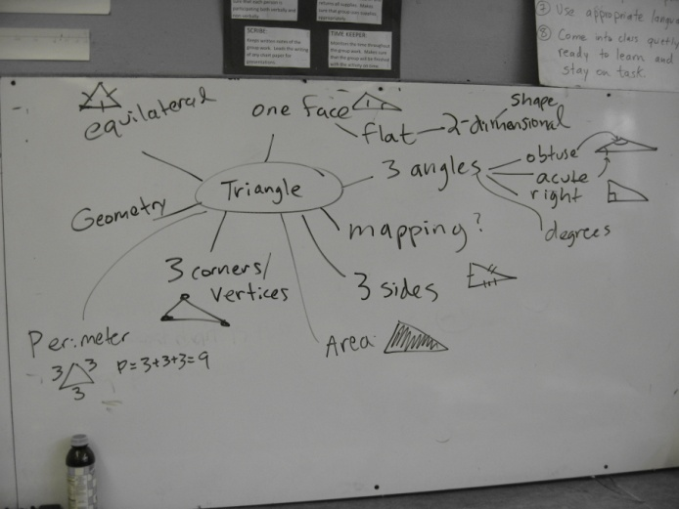
Whole Class brainstorm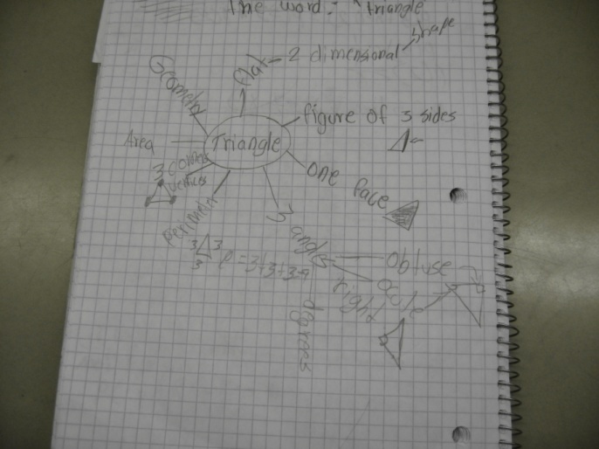 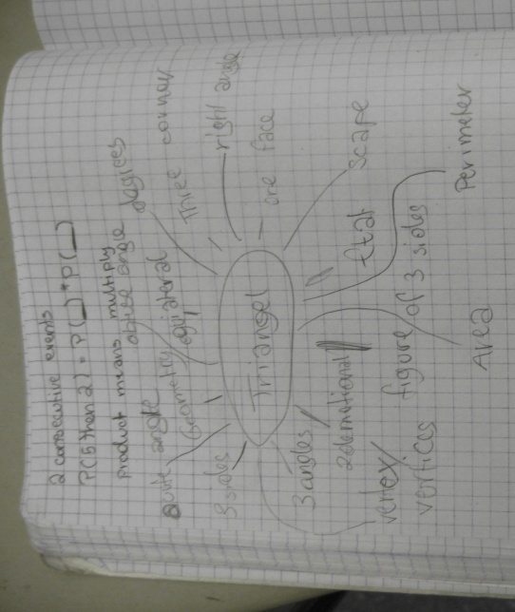 Student 1 brainstorm Student 2 brainstorm

BACKGROUND KNOWLEDGE-
Compare and Contrast Different Types of Triangles
Put an X if the fact can be true for that triangle. Example: An equilateral triangle has all equal sides.
For each X, draw a picture of an example of what you are thinking.
Fact | Equilateral Triangle | Isosceles Triangle | Scalene Triangle | Right Triangle
Has all equal sides  Picture: | X
Has 2 equal sides
Picture:

Has no equal sides
Picture:

All equal angle
Picture:

Has a right angle
Picture:

Has an acute angle
Picture:

Has an obtuse angle
Picture:

Compare/Contrast- Student Work:
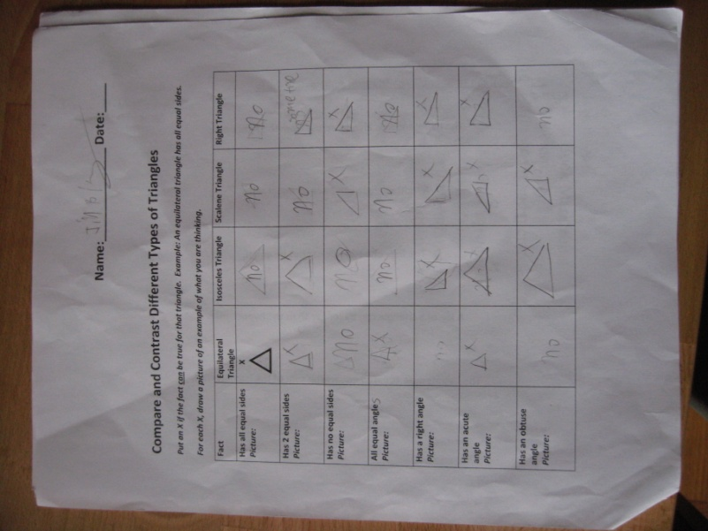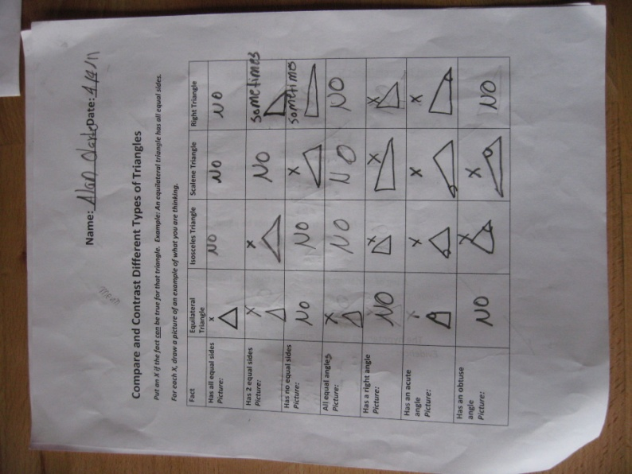

VOCABULARY- Concept Ladder
Task: Students created a concept ladder for the word Pythagorean theorem. Beginning at the top with the concept Pythagorean theorem, they will complete fill in a word, symbol or picture for each rectangle. The rectangles will be, from top to bottom: ‘concept’, ‘also called’, ‘kind of’, ‘replaced by’, ‘parts are’, ‘made (used for)’ and ‘looks like’.
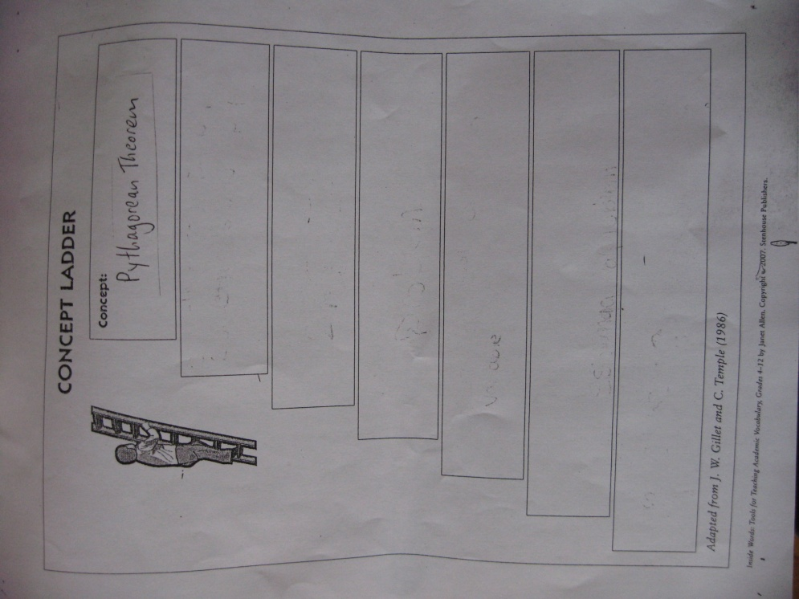

VOCABULARY- What is it?
Task: Students complete the template by putting the category of the word ‘right triangle’ in the middle rectangle. Then, on the left they write was a right triangle is not and on the right they write what a right triangle is. On the bottom, they write examples of a right triangle in the world outside the classroom. Students who have limited language can draw pictures or use their native language when they don’t know an English word.
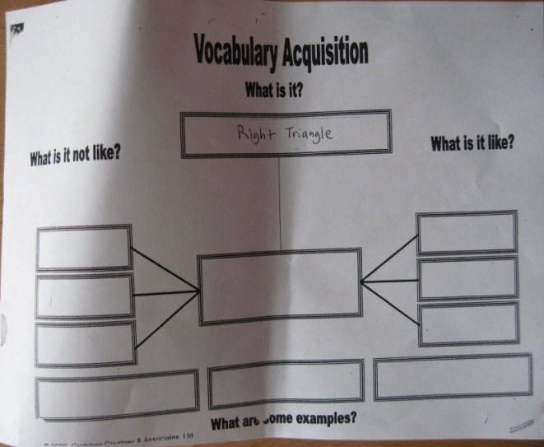
What is it?- STUDENT WORK:

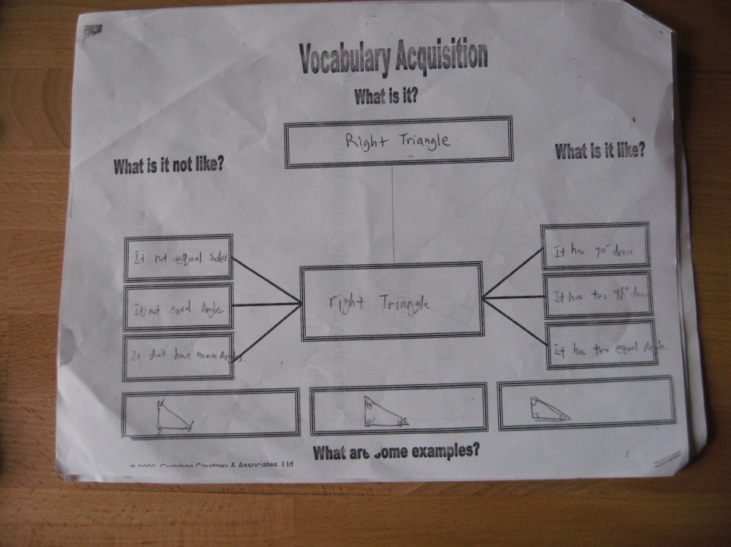
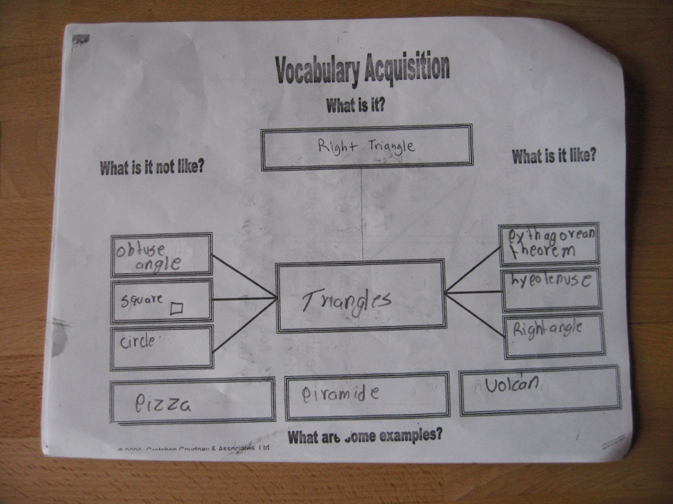

PRE-READING: Anticipation Guide
 | Class 711 | Pythagorean Theorem/Right Triangles Anticipation Guide |  | Name:
 | BEFORE |  |  | AFTER
 | Agree | Disagree | Statement | Agree | Disagree
1 |  |  | The hypotenuse is always across from the right angle.
 |  |  | Evidence:
2 |  |  | A right triangle can have all equal sides.
 |  |  | Evidence:
3 |  |  | The legs of a triangle cannot be equal.
 |  |  | Evidence:
4 |  |  | A leg of a triangle can be longer than the hypotenuse.
 |  |  | Evidence:
5 |  |  | The hypotenuse squared equals the sum of the legs squared.
 |  |  | Evidence:
Anticipation Guide- STUDENT WORK:
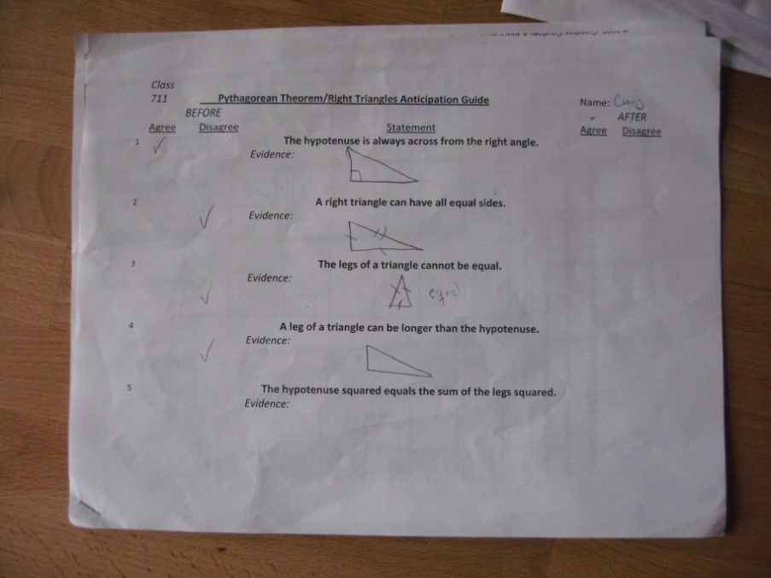

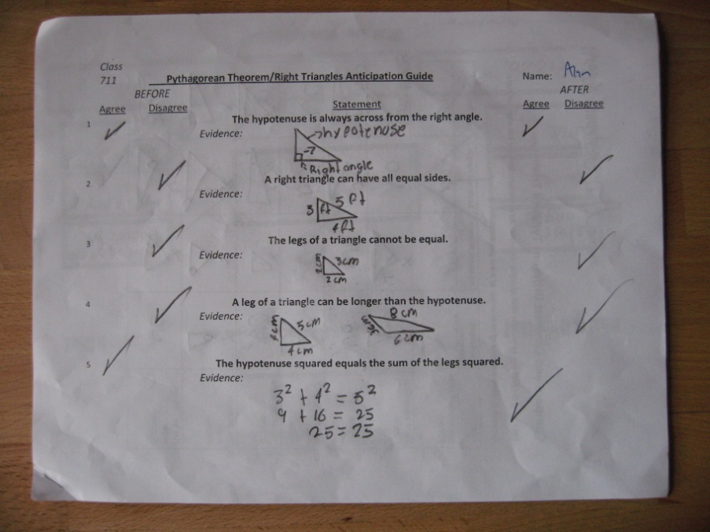

PRE-READING:
Two or Three Things I Know for Sure
TOPIC: Triangles, sides and angles.
One thing I know for sure about triangles, sides and/or angles

What makes you certain?

What could make you change your mind?

Another thing I sure about when it comes to triangles, sides and/or angles

What makes you certain?

What could make you change your mind?

Two or Three Things I Know For Sure- STUDENT WORK
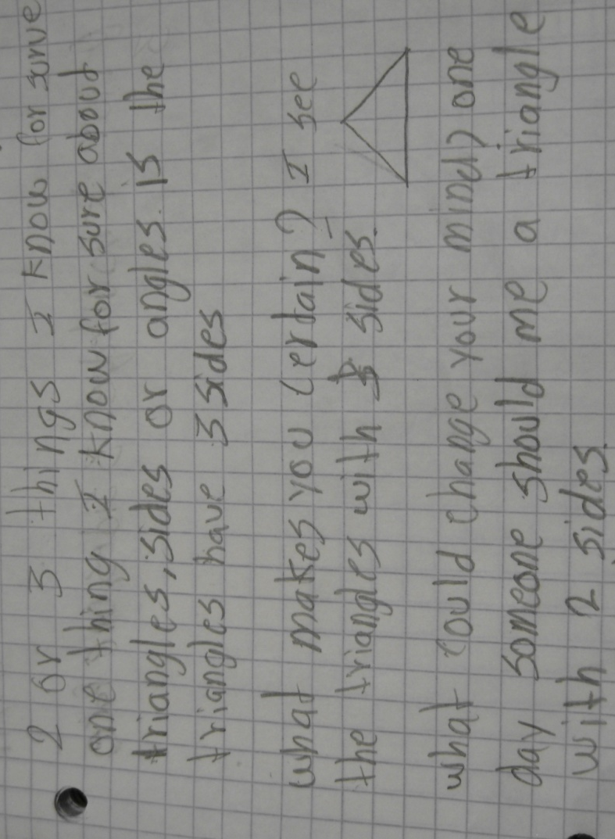
WHILE READING: Bookmark

The Ladder Problem:
A ladder is leaned against a building. The ladder is 13 feet long. The ladder reaches 12 feet on the wall. How far is the bottom of the ladder from the wall?
Bookmark- STUDENT WORK
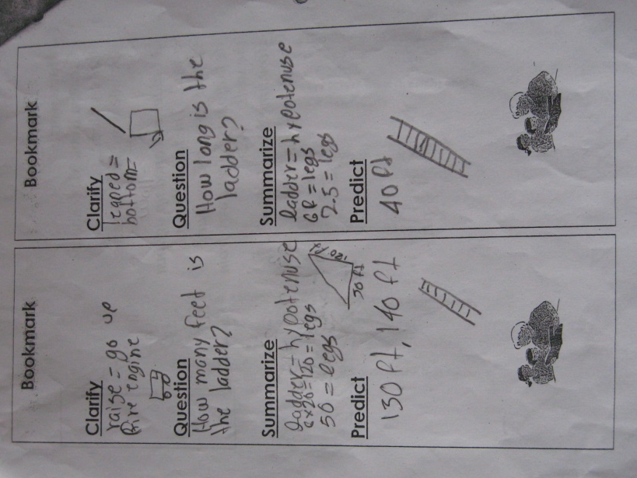
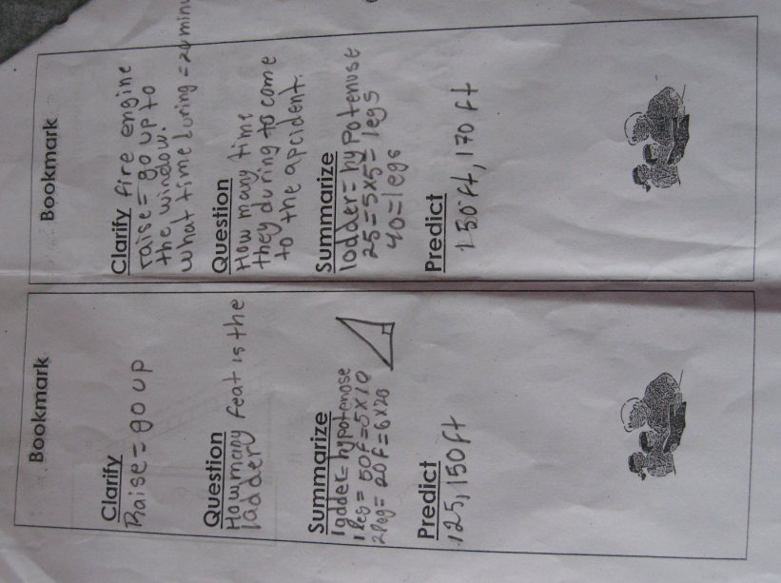

WHILE READING: Get the Gist
Students will read a problem and identify the math topic, key words, and details of the problem. They will then rephrase troublesome vocabulary and the question to help them determine a strategy to solve the problem.
Get the Gist: |  | Name:__________________________________ Date:__________
Luciano wants to know how far it is from one corner of his back yard to the other.
The dimensions of his yard are 8 meters by 6 meters.
How long is the diagonal of his back yard?
Math Topic | Key Words | Details | Student Rephrasing
Student version of the question:
Strategy/Steps:

WHILE READING: Collaborative Poster
Task: In a group, you are now going to collaborative create a mind mirror about words we have been using in this unit.
Your poster should contain:
- One quote from a problem, class notes, or your math glossary related to your word.
- One original phrase describing something about your word.
- One symbol that present your word.
- One relevant drawing.
Presentation:
- Each group will present their Mind mirror.
- Each group member is responsible for explaining one part of the poster.
Words: Hypotenuse, Right triangle, Leg, Right Angle, Acute Angle, Isosceles Right Triangle, Pythagorean Theorem

STUDENT WORK:
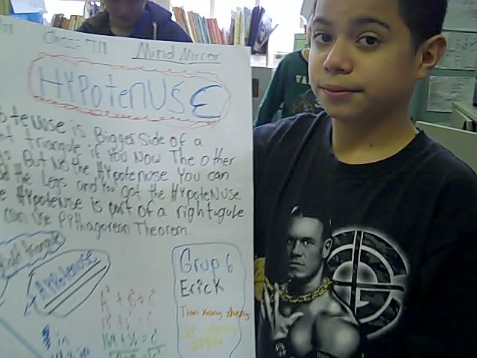
AFTER READING: 3, 2, 1
TASK: Students will listen to the presentations and write down key terminology in their notebook. We will put together a word bank. They will then use the word bank to complete a 3,2,1 template for homework. The next day they will share their templates with one another and help each other with mathematical and English accuracy. They will then go back home and turn the 3,2,1 into a paragraph.

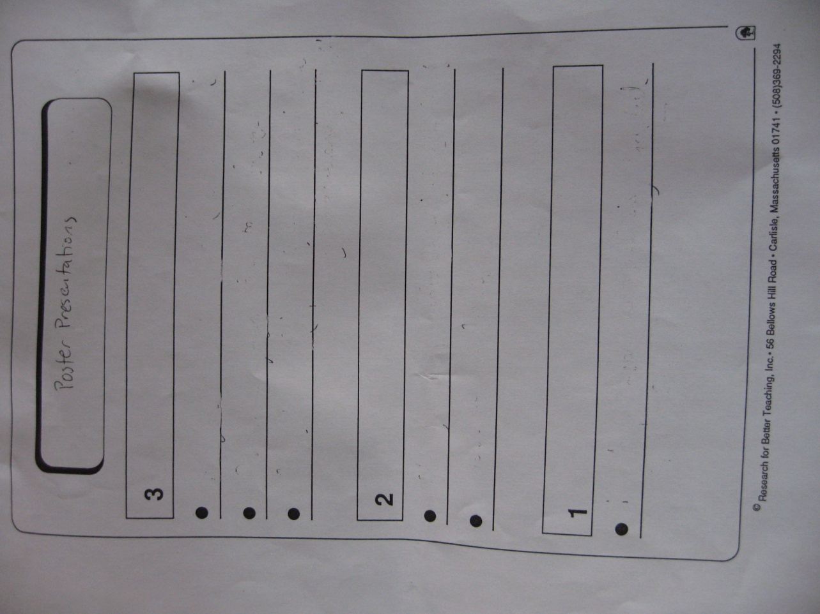

AFTER READING: Hollywood Squares
Task: Each square will have a index card in it. The category names will remain. The questions will be on one side of the index card, while the other side will feature a picture of a some geometric figure (angles, shapes, sides) which is featured in the unit. In order for students to get the opportunity to answer the question behind the geometric figure, they must first identify the geometric figure. The cards in the top row are worth 100 points, the next row 200, 300 and then 400 for the bottom row. We will keep score and students will earn points as a table.

The Triangle Family | Angles of a Triangle | Right Triangles | Pythagorean Theorem | Triangle Vocabulary

RUBRICS:
COMPARE CONTRAST RUBRIC:
Pictures could slightly vary but X’s are definitive.
28 squares, at least 24 right = level 4, 20-24 = level 3, 16-19 right = level 2, 15 or below right = level 1
Fact | Equilateral Triangle | Isosceles Triangle | Scalene Triangle | Right Triangle
Has all equal sides  Picture: | X
Has 2 equal sides  Picture: | X | X |  | X
Has no equal sides  Picture: |  |  | X | X
All equal angles  Picture: | X
Has a right angle  Picture: |  | X | X | X
Has an acute angle  Picture: | X | X | X | X
Has an obtuse angle  Picture: |  | X | X

Concept Ladder: RUBRIC
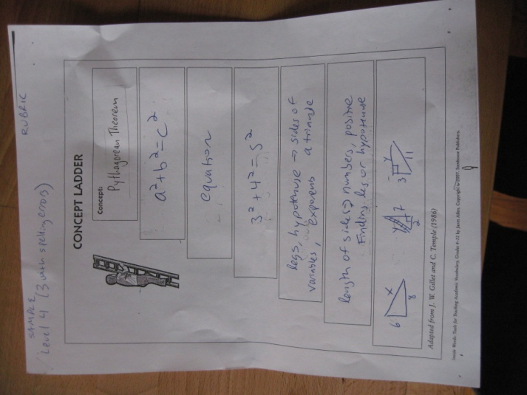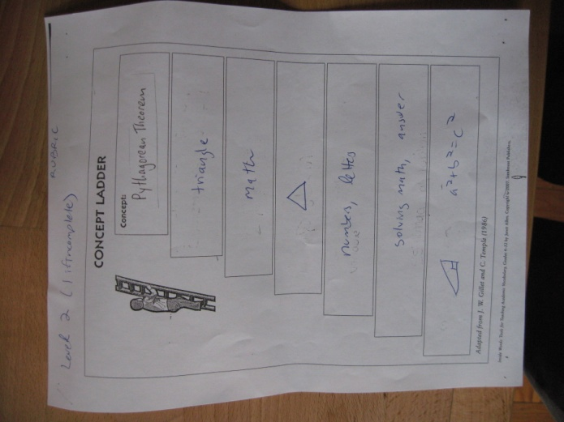
What is it? Rubric:
Level 4 – complete and 9/11 accurate,
Level 3 – mostly complete and 7/11 accurate,
Level 2 – partially complete and 5/11 accurate,
Level 1 – non complete and 3 or fewer/11 accurate.

What is it? KEY:
What is is? - Right triangle
Interior Rectangle (category) - shapes, polygons, triangles
What is it not like? - equilateral triangle, any non-triangular figure
What is it like? - isosceles triangle, scalene triangle, right angle, leg, hypotenuse
What are some examples? – any real life examples of a right triangle, side of house, ramp,

 | Class 711 | Pythagorean Theorem/Right Triangles Anticipation Guide RUBRIC |  | Name:
 | BEFORE |  |  | AFTER
 | Agree | Disagree | Statement | Agree | Disagree
1 | Either acceptable |  | The hypotenuse is always across from the right angle. | X
 |  |  | Evidence: They can draw a picture and label the triangle or
 |  |  | explain in full sentences, indicating where the hypotenuse is
2 | Either acceptable |  | A right triangle can have all equal sides. |  | X
 |  |  | Evidence: They can draw a picture and label the triangle or
 |  |  | explain in full sentences. It is impossible to make a right angle
 |  |  | and have equal sides.
3 | Either acceptable |  | The legs of a triangle cannot be equal. |  | X
 |  |  | Evidence: They should just draw an isosceles triangle of any kind.
4 | Either acceptable |  | A leg of a triangle can be longer than the hypotenuse. |  | X
 |  |  | Evidence: Student can write or draw a picture that shows that
 |  |  | the legs are the shorter sides and the hypotenuse is the long
 |  |  | side across from the right angle.
5 | Either acceptable |  | The hypotenuse squared equals the sum of the legs squared. | X
 |  |  | Evidence: This is the Pythagorean theorem in words. They
 |  |  | could write it out in symbols and/or draw a labelled picture.

Get the Gist: RUBRIC |  | Name:__________________________________ Date:__________
Luciano wants to know how far it is from one corner of his back yard to the other.
The dimensions of his yard are 8 meters by 6 meters.
How long is the diagonal of his back yard?
Math Topic | Key Words | Details | Student Rephrasing
Geometry | backyard | rectangle | The back yard is a rectangle.
 | dimensions | 8 meters by 6 meters | The length of the backyard is 8 m. The width is 6 m.
 | diagonal | divides the rectangle into 2 right triangles | The diagonal is the distance from one corner to another.
Pythagorean Theorem | how long | we don't know | The distance from one corner to another.
 | how far | we don't know | The distance along the diagonal.
Student version of the question:
Luciano's yard is 8 meters in length and 6 meters in width. We have to find the distance from one corner to another in meters.
Strategy/Steps:
I will use the Pythagorean theorem to find the answer. I will find 6 squared and 8 squared and add them together. Then I will find the square root and that will
be the distance in meters from one corner of the back yeard to the other.
Students' responses may vary in order and detail of language. Points will be taken off for coherency but not for simple spelling or grammatical errors.

Collaborative Poster: RUBRIC
- Level 4- Group member participated in group work and presented one of the ideas from the poster.
- Level 3- Group member somewhat participated in group work and presented one of the ideas from the poster.
- Level 2- Group member participated somewhat or little in group work and/or may not have presented one of the ideas from the poster.
- Level 1- Group member participated little in group work and/or did not have presented one of the ideas from the poster.
3, 2,1 RUBRIC: (graduate rubric)
Intermediate ELL
4 – Paragraph is written in complete sentences and utilizes math content vocabulary. Sentences are understandable but may contain some grammatical and syntax errors. There are connecting words like first, last, also, and next. Sentences are included that were not on 3,2,1 sheet.
3- The majority of the paragraph is in complete sentences and contains some (possible misapplied) math content vocabulary. Most sentences are understandable but contain grammatical and syntax errors. There are some but possibly misapplied connecting words like first, last, also, and next. Sentences are attempted that were not on 3,2,1 sheet, but troubles communicating.
2- Paragraph is not in complete sentences, primarily. There is very little math content vocabulary and it is hard to understand because of excessive errors. May have attempted sentences that are not included on 3,2,1 sheet, but are incomprehensible.
1- Paragraph is incomplete possibly not written in English. Math content vocabulary is nonexistent or misapplied. It is very difficult to understand the paragraph. Nothing exists that was not on the 3,2,1 sheet.
Beginning ELL
4 – Paragraph is written in complete sentences and utilizes math content vocabulary. Sentences are understandable but may contain some grammatical and syntax errors.
3- The majority of the paragraph is in complete sentences and contains some (possible misapplied) math content vocabulary. Most sentences are understandable but contain grammatical and syntax errors.
2- Paragraph is not in complete sentences, primarily. There is very little math content vocabulary and it is hard to understand because of excessive errors.
1- Paragraph is incomplete possibly not written in English. Math content vocabulary is nonexistent or misapplied. It is very difficult to understand the paragraph.

Reflection: Right Triangles and the Pythagorean Theorem Unit Sage Forbes-Gray
As an educator, the Right Triangles and Pythagorean Theorem Unit has always been a challenge. It is the first time in the 7th-grade curriculum when students are learning something of which they have very little prior knowledge. Yes, they understand squaring, working with equations and know ways to differentiate triangles. Nevertheless, it is the first time they are told there is a connection between the sides of a right triangle and a formula to find the missing side. Due to its novelty and large amount of new vocabulary, it is both an exciting and difficult moment for students. In order to meet the vocabulary demands of this unit, I was excited to implement ELL strategies to help promote my students’ success.
Another challenge in my classroom is that the students are grouped primarily based on language ability and not at all on mathematics competency. I wanted to make sure that the material was accessible to a small range of language abilities and a large range of mathematical abilities. Outside of my studies at Touro College, I have participated in a National Science Foundation lesson study group on the importance of semiotics in math teaching. Semiotics is the connection between semantics, syntax and pragmatics in language and can be conveyed with words, symbols, pictures or diagrams. I thought the most effective way to maximally support all my students was to use various semiotic representations in my models.
In order to achieve visual connection to the unit, I added a pictorial component to my ‘Compare and Contrast’ and ‘What is It?’ activities. Students used pictures most often when they did not know the words to describe their thinking, but it was also a great way to draw in lower level learners, while still challenging more advanced learners. The Collaborative Poster is visual in its nature, but I pushed students to include diagramming into their posters as well. In general, ELL strategies provide a bridge between visual templates and more formal writing, which is essential when learning how to communicate effectively in a second (or third) language. The ‘2 or 3 things I know for sure’ activity and the ‘3,2,1’ activity both help students organize their thoughts into coherent English sentences and paragraphs. I noticed marked improvement in my students writing when they began with a template.
I was most impressed with the way that an ELL strategy could help students break down their mathematical thinking in arduous word problems and inspire connections between current thinking and prior knowledge. The ‘Bookmark’ strategy and ‘Get the Gist’ both gave students a manageable structure to sift through relevant information in a word problem and develop a plan for how to solve the problem. Students found Pythagorean Theorem problems, which are notoriously challenging in their language, much easier to solve using the ‘Bookmark’ and ‘Get the Gist’ activities. I also noticed that students were better able to sift through information that they heard and better able to communicate spoken ideas because of these strategies.
In the past, students have found it challenging to do presentations for each other and to be active audience members when listening to presentations. The ‘3,2,1’ strategy allowed them to focus their listening during presentations and all the ELL strategies in this unit allowed students to be more confident when speaking in front of the class. We have not yet done the ‘Hollywood Squares, but previous experience tells me my students love games and competition (even the ones that come from less competitive cultures). I think ‘Hollywood Squares’ will be a great culminating review activity before the unit test next week.
Overall, I enjoyed focusing on ELL strategies in the Right Triangle and Pythagorean Theorem unit. Although I found testing out ELL strategies to be useful throughout the semester, making a concerted effort to incorporate ELL strategies into an entire unit really convinced me. The students are excited and learning much more effectively than ever before.
Action Plan: Right Triangles and the Pythagorean Theorem Unit Sage Forbes-Gray
Since I was fortunate enough to already be able to implement the first part of this unit, I have seen the positive results of focusing of ELL strategies in content area teaching. I am looking forward to finishing the Pythagorean Theorem unit with my 7th graders and seeing if their unit test performance improves. Although my goals for my students extend beyond their test performance, the world I teach in and that my students learn in is one where high stakes testing is the greatest hurdle. Formative assessments throughout the unit have already shown me that my students are getting better at tackling word problems and communicating effectively.
This experience is proof that ELL strategies, although often time consuming, are worth the effort. Students are excited about learning when I use ELL strategies. Their anxiety level is noticeably lower because they are not constantly struggling to understand the material I am presenting. It is clear that it is better for them emotionally to use ELL strategies. As teachers, we are always under pressure to keep moving and get through the curriculum, but year after year the students don’t seem to retain very much. For the rest of the year, I am going to try to slow down a little bit and perhaps only cover 80-90% of the topics, but cover them well.
When I begin my next unit plan, I will not only write content objectives but also language objectives and think specifically about which ELL strategies will help my students meet their language and content objectives. I am proud of the unit I created for Right Triangles & the Pythagorean Theorem, but in the future I will try to reduce the amount of text on a page and provide fewer, more meaningful examples instead of cluttering activities with too much information. Finally, I will continue to work on how I introduce new strategies and models so that students can grasp and apply them more quickly and effectively.

