|  |  |
| --- | --- |
| **Unit of Study:** State Lotteries **Time:** 1 pd **Date:**  Week of 4/22, Lesson 1  **Essential Question(s):**  Who plays the lottery, why? How does the lottery differ from state to state?  **Focus Question:**  How do we understand the odd of winning the lottery?  **Language Objective:** SWBAT compare odds of different events happening using greater/less than.  SWBAT describe different representations of odds verbally to one another.  SWBAT listen to a video about wealth and connect the video to large numbers in the lottery. | |
| **Materials Needed:** station boxes with representations, pencils, pens, chart paper, computers, , laptop (java script & cookies enabled), internet, ipad, projector, elmo, colored pencils/markers, group roles, calculators | **Vocabulary:**  Lottery, Gambling, Chance, Fair, Statistic, Probability, Sample Space,Theoretical/Experimental/Conditional/Independent/Dependent/Compound/Simple/Single Event/Multiple-Event Probability; want/desire; Prediction, Results, Compare, Order, Decide, Analyze, Determine, Conclude, Distinguish, Bias, Targeted Audience, Revenue, Percent, Decimal, Fraction, Funding, Private, Governmental, Successful, Win, Lose/Loss, Prize Structure, Multi-State, Generate, Self-Selected, Computer Generated, Cost, Estimated Gain, Percent Error, Pay Off |
| **Do Now:** Eight and a half million people live in New York. How big is that really? How could you show how big that is?  *Students get a calculator on the way in.* | |
| **Teach:  *Understanding Odds - Small and Very Small***  **Odds** can involve very large numbers.  *How many ways could we roll 2 dice?   What were the odds of getting double 4’s?  How about a 4 & a 1?*  2 2 1  *How many numbers could come up in FG ? What were the odds of our number coming up?*  What are the odds of you getting chosen at random in all of NYC?  What does this look like on the scientific calculator? | |
| **Guided Practice:**  *Complete these sentences using the information in your station and your research.*  The odds of rolling double 4s are _____.  The odds of getting your number in FG lotto are ____.  The odds of __________________ are ______.  The odds of __________________ are _____.  The odds of __________________ are ______.  The odds of __________________ are _____.  The odds of winning the NY lottery's top prize is ____.  The odds of winning the ________ lottery's top prize is ____.  *\*\*\*\*Use the above sentences to write 5 comparative statements.\*\*\*\*\**  ***Example:*** The odds of getting struck by lighting are ________ than being attacked by a shark. (greater/less).  Use your calculator to help you develop your sentences.  **Computer Distribution:** (*Make-up kids from last week)*  Once you get YOUR computer, take a seat.  Turn on your computer.  Open the web browser.  Go to ***www.fgsmathcorner.weebly.com***  ***Begin to look at the advertisements for your two state lottery* systems.** | |
| **Independent Practice:**  Students will be grouped according to their lottery state and work on comparing odds to their lottery systems with the aid of the calculator. They will work in groups looking at different representations of the odds of non-lottery events and then as a group (enrichment) come up with a representation for winning the lottery for their state (give them the freshwater example as an option. They can use chart paper or the computer for their representation.    *While circulating, I will ask the following questions to students: what is the least likely prize? What is the most likely prize? How much more likely is ______ than ______? How do you compare the likelihood using fractions? Does odds have to be expressed as a fraction? Would that change how your compared it to another odd?* | |
| **Class share:**  We will do *Pass the Paper* sharing our different representations of winning the lottery. Also, we will share out our comparative sentences as a whole class/between groups/or in pairs. | |
| **Homework:** Scientific notation JMap problems | |
| **Post-Lesson Reflection** | |

|  |  |
| --- | --- |
| **Unit of Study:** Locks, Lotto & Lineage **Time:** 1 pd **Date:**  Week of 3/4, Lesson 3  **Essential Question(s):** What is the difference between Experimental and Theoretical Probability? What is the difference between what did happen and what will happen? How do I know I have counted all the possibilities?  **Focus Question:** How do we prepare for the DYO?  **Language Objective:** SWBAT brainstorm words connected to linear equation using a graphic organizer AND SWBAT work through misunderstanding in stations using the question steps. | |
| **Materials Needed:** student notebooks, pencils, pens, chart paper, computers, graph paper, laptop, ipad, projector, elmo, station copies (10/ station), station instructions copies (10 copies total), baskets. | **Vocabulary:** event sample space likelihood  chance random outcome  decision probability ratio same different connection apply sort justify percent  lock password code digit sure certainty repeat |
| **Do Now:** What do you remember about the following words? | |
| **Teach:**  **Stations (5 minutes for each):**  1) Experimental Probability 2) Theoretical Probability  3) Graphing/Describing Data 4) Line of best fit/Correlation/Predictions  5) Calculating Slope/Y-intercept 6) Writing linear equations/Substitution | |
| **Guided Practice:** First, we will discuss ***Station Norms***:   1. Stay in your station for the full time. 2. Do all problems and show all work in your notebook. 3. If confused, use the question steps. 4. Listen for the time to rotate and move quickly to the next station.   We will walk through the 4 stations. Identifying key words, representations and hints. | |
| **Independent Practice:** Students will move between stations (10 minutes each). I will circulate giving assistance and asking higher order questions. *What connections do you see between the station/questions? What questions could be part of this station? What confusion might another student have? How would you help them with that confusion?* | |
| ***3, 2, 1 Reflection: 3 things I learned/remembered today, 2 questions I still have,***  ***1 interesting/important thing someone said today.*** | |

|  |  |
| --- | --- |
| **Unit of Study:** State Lotteries **Time:** 1 pd **Date:**  Week of 4/22, Lesson 2  **Essential Question(s):**  How does the lottery differ from state to state?, How likely is it that someone will win? What will they win?  **Focus Question:**  How do we compare different single odds of winning between state lottery systems?  **Language Objective:** SWBAT write sentences about probability, likelihood and odds.  SWBAT read and interpret graphical representations of probability and the lottery.  SWBAT use comparative words like greater than or less than verbally and in writing. | |
| **Materials Needed:** pencils, pens, chart paper, computers, internet, laptop, ipad, projector, elmo, chart paper for 4- square model | **Vocabulary:**  Lottery, Gambling, Chance, Fair, Statistic, Probability, Sample Space, Theoretical/Experimental/Conditional/Independent/Dependent/Compound/Simple/Single Event/Multiple-Event Probability; want/desire; Prediction, Results, Compare, Order, Decide, Analyze, Determine, Conclude, Distinguish, Bias, Targeted Audience, Revenue, Percent, Decimal, Fraction, Funding, Private, Governmental, Successful, Win, Lose/Loss, Prize Structure, Multi-State, Generate, Self-Selected, Computer Generated, Cost, Estimated Gain, Percent Error, Pay Off |
| **Do Now:** Which of your two lottery systems would you rather play? Why? | |
| **Teach**   **Mini-Lesson:** *Comparing Odds*  When the **odds** are ***higher***, you are more likely to win.  When the ____ are _____, you are ________  to ____.    P(A) = *the probability of A*  *Who can think create another notation similar to P(A)? What would be call it? What is the rule for writing the notation? What if we wanted to write the probability of 2 events? Who can predict how that might be written? What if we want to write about the probability of something not happening?* | |
| **Guided Practice:**  Compare the following odds: *The probability of ___________ is _______ than the probability of ___________.*  **The probability of flipping a head. The probability of rolling a 2 and a 3.**    **Computer Distribution: (*make-up kids – last week)***  Once you get YOUR computer, take a seat.  Turn on your computer.  Open the web browser.  Go to ***www.fgsmathcorner.weebly.com***  ***Begin to look at the advertisements for your two state lottery* systems** | |
| **Independent Practice:**  Record 3 odds for EACH of your state lottery systems.  Write 2 comparative sentences using greater than and less than within the SAME lottery system.  Write 3 comparative sentences using greater than and less than between DIFFERENT lottery system.  Order all of your odds from least to greatest.  *How can we tell which odd is the least? How would you explain that to someone who is having trouble understanding? Since fractions, decimals and percents are the same, can we express odd with all of them? Which one is easiest for you? Why?*  **Extension: *Deeper Questions***  How can we write questions using the following words:  *at least at most less than greater than*  **i.e. What are the odds of winning at least $10,000?**  **P($10,000)+P($1,000,000)+P(jackpot)**  Write 3 of your own questions. Choose one to investigate and answer. | |
| ***Summary:***  Share your work with a partner.  Explain and justify your final ordering aloud.  Write your justification under your ordering. | |
| **Homework:** Single Event probability review jmap problems | |
| **Post-Lesson Reflection** | |

|  |  |
| --- | --- |
| **Unit of Study:** State Lotteries **Time:** 1 pd **Date:**  Week of 4/22, Lesson 3  **Essential Question(s):**  How does the lottery differ from state to state?, How likely is it that someone will win? What will they win?  **Focus Question:** How do we compare different multiple event odds of winning between state lottery systems?  **Language Objective:** SWBAT | |
| **Materials Needed:** student survey cards pencils, pens, chart paper, computers, internet, laptop, ipad, projector, elmo, chart paper for 4- square model | **Vocabulary:**  Lottery, Gambling, Chance, Fair, Statistic, Probability, Sample Space, Theoretical/Experimental/Conditional/Independent/Dependent/Compound/Simple/Single Event/Multiple-Event Probability; want/desire; Prediction, Results, Compare, Order, Decide, Analyze, Determine, Conclude, Distinguish, Bias, Targeted Audience, Revenue, Percent, Decimal, Fraction, Funding, Private, Governmental, Successful, Win, Lose/Loss, Prize Structure, Multi-State, Generate, Self-Selected, Computer Generated, Cost, Estimated Gain, Percent Error, Pay Off |
| **Do Now:**  How does this diagram represent a Powerball drawing? | |
| **Teach/Guided Practice:** | |
| **Independent Practice (*Reg/Enrichment)*:**   **Independent Practice:** *Answer the following about NY & your state.*  1) How many events are in your state lottery?  2) Draw a flowchart for your lottery?  3) What is one possible number that could be drawn first?  4) Does the first number affect the 2nd, 3rd.... number drawn?  5) What events are dependent in your lottery system?  6) What events are independent in your lottery system?  ***Answer questions 1-6 for NY.***  ***When finished, turn your answers into one NY and one other state paragraph.***  What similarities and differences exist with dependence? (Enrichment)  **Computer Distribution: (*make-up kids- last week’s work)***  Once you get YOUR computer, take a seat.  Turn on your computer.  Open the web browser.  Go to ***www.fgsmathcorner.weebly.com***  ***Begin to look at the advertisements for your two state lottery* systems.** | |
|  | |
| **Homework:** Finish your *Scientific notation* and *Simple probability* Jmap sheets, if not complete. | |
| **Post-Lesson Reflection** | |

NY POWERBALL: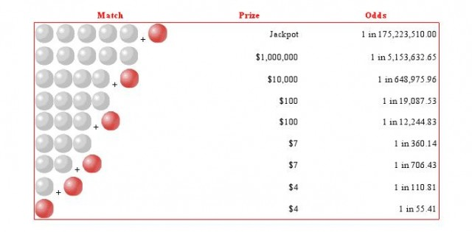

MEGAMILLIONS:

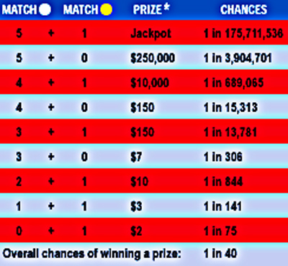

SUPER DRAW:

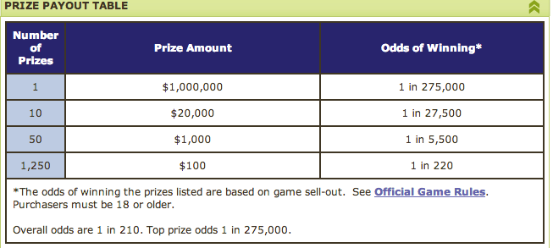

DAILY NUMBER:

| **Description of Bet Types** | **Payout** | **$.50 Bet** | **$1 Bet** | **$2 Bet** | **$3 Bet** | **$4 Bet** | **$5 Bet** |
| --- | --- | --- | --- | --- | --- | --- | --- |
| **PLAY IT STRAIGHT:**Play any three digits. Only exact match wins. | 500 to 1 | $250 | $500 | $1,000 | $1,500 | $2,000 | $2,500 |
| **PLAY IT BOXED:**BOX any three different digits. If number is drawn in any order, you win. | 80 to 1 | $40 | $80 | $160 | $240 | $320 | $400 |
| **BOX TWO DIGITS + ONE:**Play two of the same digit + one. If number is drawn in any order, you win. | 160 to 1 | $80 | $160 | $320 | $480 | $640 | $800 |
| **PLAY FRONT PAIR:**Play two digits. The two digits you choose must be in front. Only exact match wins. | 50 to 1 | $25 | $50 | $100 | $150 | $200 | $250 |
| **PLAY BACK PAIR:**Play two digits. The two digits you choose must be in back. Only exact match wins. | 50 to 1 | $25 | $50 | $100 | $150 | $200 | $250 |
| **PLAY SUPER STRAIGHT:**Play straight all combinations of any three different digits. | 500 to 1 | $.50 bet = $3.00, pays $250 | | | | | |
| **PLAY SUPER STRAIGHT:**Play straight all combinations of any two same digits + one. | 500 to 1 | $.50 bet = $1.50, pays $250 | | | | | |

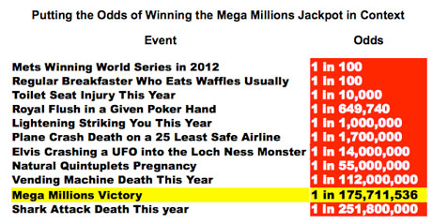

**Guided Practice:**  *Complete these sentences using the information in your station.*

The odds of rolling double 4s are _____.

The odds of getting your number in FG lotto are ____.

The odds of __________________ are ______.

The odds of __________________ are _____.

The odds of __________________ are ______.

The odds of __________________ are _____.

The odds of winning the NY lottery's top prize is ____.

The odds of winning the ________ lottery's top prize is ____.

*\*\*\*\*Use the above sentences to write 5 comparative statements.\*\*\*\*\**

***Example:*** The odds of getting struck by lighting are ________ than being attacked by a shark. (greater/less).  Use your calculator to help you develop your sentences.

**1.**

**2.**

**3.**

**4.**

**5.**

**Guided Practice:**  *Complete these sentences using the information in your station.*

The odds of rolling double 4s are _____.

The odds of getting your number in FG lotto are ____.

The odds of __________________ are ______.

The odds of __________________ are _____.

The odds of __________________ are ______.

The odds of __________________ are _____.

The odds of winning the NY lottery's top prize is ____.

The odds of winning the ________ lottery's top prize is ____.

*\*\*\*\*Use the above sentences to write 5 comparative statements.\*\*\*\*\**

***Example:*** The odds of getting struck by lighting are ________ than being attacked by a shark. (greater/less).  Use your calculator to help you develop your sentences.

**1.**

**2.**

**3.**

**4.**

**5.**

**Scientific Notation- Jmap Homework**

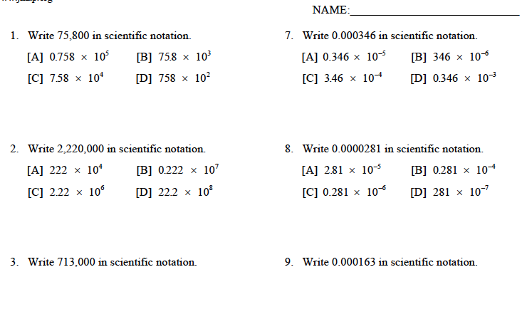

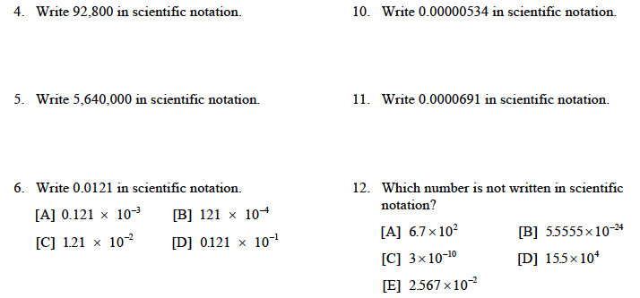

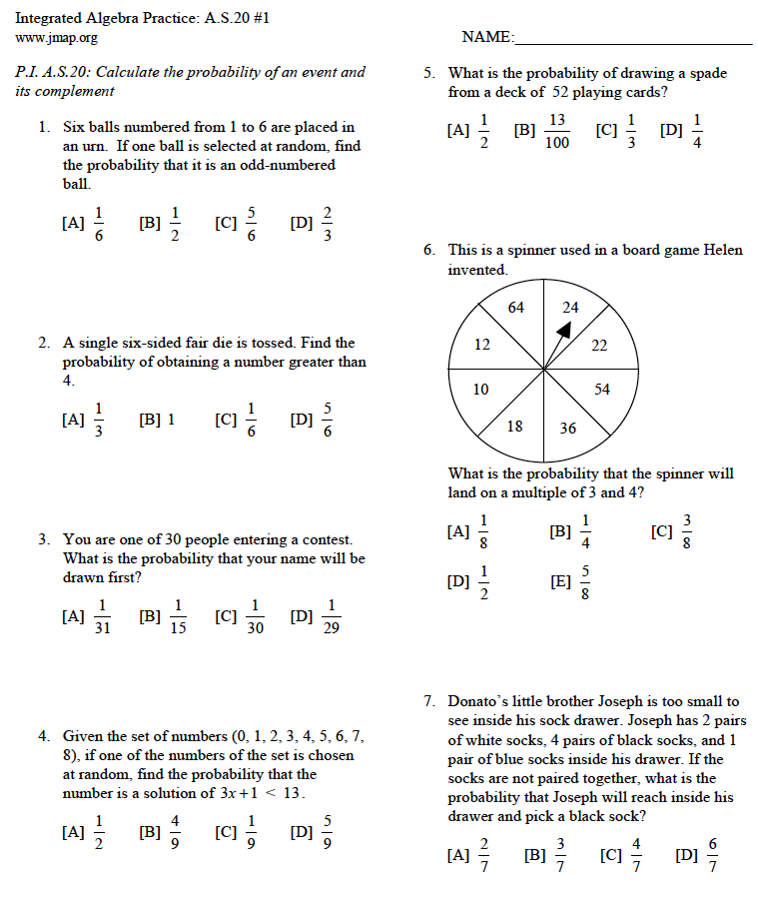

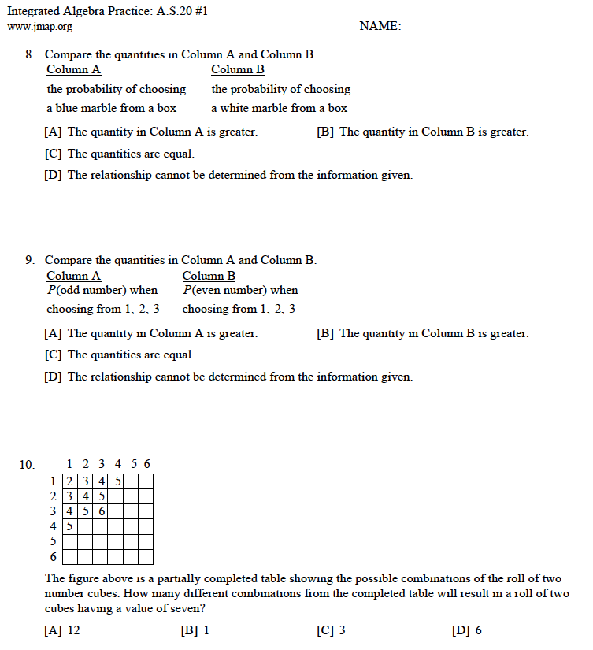

taking odds and comparing them

- comparing fractions, winning a set amount of money – **top prize, any prize (add all odds), at least $x**

- not winning- **top prize, any prize, at least $x**

- winning this or more, this or less

- comparing magnitudes, connection to scientific notation – **put values in calculator, e, table, sci not rev**

Conditional probability- **if your have gotten all the right numbers and you only have one left, what are your odds of winning? What are your odds of losing? -*connect to regent’s probs- books***

*Some books are laid on a desk. Two are English, three are mathematics, one is French, and four are social studies. Theresa selects an English book and Isabelle then selects a social studies book. Both girls take their selections to the library to read. If Truman then selects a book at random, what is the probability that he selects an English book?*

Prove odds?  - casino context, tie in lottery- exit slip, reflection

* **sample space ? maybe week 2?**
* ***Same wk as sample space, Rev Permutation and Combination notation on regent’s***

Symposium prep- wk or 2 wks, regents prep- probability related questions

- improvements, continuation, differentiated

Regent's prep- **Cond Prob Jmap Regent’s prob file- *rev P(A) and teach P(A not B) notation***