|  |  |
| --- | --- |
| **Unit of Study:** State Lotteries **Time:** 1 pd **Date:**  Week of 4/8, Lesson 1  **Essential Question(s):**  Who plays the lottery, why? How does the lottery differ from state to state?  **Focus Question:** How do we examine advertisements for the lottery?  **Language Objective:** SWBAT identify motives and propaganda in lottery advertisements. | |
| **Materials Needed:** student survey cards pencils, pens, chart paper, computers, , laptop (java script & cookies enabled), internet, ipad, projector, elmo, survey cards | **Vocabulary:**  Lottery, Gambling, Chance, Fair, Statistic, Probability, Sample Space,Theoretical/Experimental/Conditional/Independent/Dependent/Compound/Simple/Single Event/Multiple-Event Probability; want/desire; Prediction, Results, Compare, Order, Decide, Analyze, Determine, Conclude, Distinguish, Bias, Targeted Audience, Revenue, Percent, Decimal, Fraction, Funding, Private, Governmental, Successful, Win, Lose/Loss, Prize Structure, Multi-State, Generate, Self-Selected, Computer Generated, Cost, Estimated Gain, Percent Error, Pay Off |
| **Do Now:** What do you notice about this ad? | |
| **Teach: Mini-lesson:**  A **motive** is the reason that someone/something is doing something.  Example: *My* ***motive*** *for giving your homework is so you can practice what we do in class. (****motive= motivation)***  **Propoganda** is an advertisement that has a specific **motive.**  Question: Is all advertising propoganda? Are there other kinds of propoganda?  Discuss the question with your partner. Be prepared to share. | |
| **Guided Practice:**    **Computer Distribution:**  Once you get YOUR computer, take a seat.  Turn on your computer.  Open the web browser.  Go to ***www.fgsmathcorner.weebly.com***  ***Begin to look at the advertisements for your two state lottery* systems.** | |
| **Independent Practice:**  Student will conduct on line research on two lottery systems using their graphic organizers and the [www.fgsmathcorner.weebly.com](http://www.fgsmathcorner.weebly.com) website.  **Pair work:**  Work with a partner to complete the chart about NY Powerball.  **Individual work:**  Work individually to complete the chart about your other State Lottery system. | |
| **Homework:**  What other examples of propaganda do you see in advertisements on the subway, on the street, and on TV?  Write a reflection of your thoughts (sentences, words, pictures, diagrams) | |
| **Post-Lesson Reflection** | |

|  |  |
| --- | --- |
| **Unit of Study:** Locks, Lotto & Lineage **Time:** 1 pd **Date:**  Week of 3/4, Lesson 3  **Essential Question(s):** What is the difference between Experimental and Theoretical Probability? What is the difference between what did happen and what will happen? How do I know I have counted all the possibilities?  **Focus Question:** How do we prepare for the DYO?  **Language Objective:** SWBAT brainstorm words connected to linear equation using a graphic organizer AND SWBAT work through misunderstanding in stations using the question steps. | |
| **Materials Needed:** student notebooks, pencils, pens, chart paper, computers, graph paper, laptop, ipad, projector, elmo, station copies (10/ station), station instructions copies (10 copies total), baskets. | **Vocabulary:** event sample space likelihood  chance random outcome  decision probability ratio same different connection apply sort justify percent  lock password code digit sure certainty repeat |
| **Do Now:** What do you remember about the following words? | |
| **Teach:**  **Stations (5 minutes for each):**  1) Experimental Probability 2) Theoretical Probability  3) Graphing/Describing Data 4) Line of best fit/Correlation/Predictions  5) Calculating Slope/Y-intercept 6) Writing linear equations/Substitution | |
| **Guided Practice:** First, we will discuss ***Station Norms***:   1. Stay in your station for the full time. 2. Do all problems and show all work in your notebook. 3. If confused, use the question steps. 4. Listen for the time to rotate and move quickly to the next station.   We will walk through the 4 stations. Identifying key words, representations and hints. | |
| **Independent Practice:** Students will move between stations (10 minutes each). I will circulate giving assistance and asking higher order questions. *What connections do you see between the station/questions? What questions could be part of this station? What confusion might another student have? How would you help them with that confusion?* | |
| ***3, 2, 1 Reflection: 3 things I learned/remembered today, 2 questions I still have,***  ***1 interesting/important thing someone said today.*** | |

|  |  |
| --- | --- |
| **Unit of Study:** State Lotteries **Time:** 1 pd **Date:**  Week of 4/8, Lesson 2  **Essential Question(s):**  How does the lottery differ from state to state?, Where does the money from the lottery go?, Who owns the lottery?, How likely is it that someone will win? What will they win?  **Focus Question:** How do we investigate media coverage of the lottery?  **Language Objective:** SWBAT read and answer questions about newspaper articles and websites about the lottery.  SWBAT identify and discuss bias and motive in newspaper articles and websites about the lottery.  SWBAT state a position and an opposing position about an article. | |
| **Materials Needed:** student survey cards pencils, pens, chart paper, computers, internet, laptop, ipad, projector, elmo, chart paper for 4- square model | **Vocabulary:**  Lottery, Gambling, Chance, Fair, Statistic, Probability, Sample Space, Theoretical/Experimental/Conditional/Independent/Dependent/Compound/Simple/Single Event/Multiple-Event Probability; want/desire; Prediction, Results, Compare, Order, Decide, Analyze, Determine, Conclude, Distinguish, Bias, Targeted Audience, Revenue, Percent, Decimal, Fraction, Funding, Private, Governmental, Successful, Win, Lose/Loss, Prize Structure, Multi-State, Generate, Self-Selected, Computer Generated, Cost, Estimated Gain, Percent Error, Pay Off |
| **Do Now:** What is your reaction to this headline?  ***Company running N.Y. Lottery games has history of scandal*** | |
| **Teach** | |
| **Guided Practice:**   **Computer Distribution:**  Once you get YOUR computer, take a seat.  Turn on your computer.  Open the web browser.  Go to ***www.fgsmathcorner.weebly.com***  ***Begin to look at the advertisements for your two state lottery* systems** | |
| **Independent Practice:** Student will conduct on line research on two lottery systems using their graphic organizers and the [www.fgsmathcorner.weebly.com](http://www.fgsmathcorner.weebly.com) website. | |
| ***Summary:*  Position Paper/Paragraph:**  1) Look over your notes on the articles.  2) Choose one article that you have an opinon about.  3) Write a paragraph defending your opinion on one of the articles.  *Include: evidence from the article, personal experience, outside knowledge*  ***Scaffolded Position Paragraph:***  *I am writing about __________.*  *I think that ...*  *The reason I believe that is ....*  *Another reason I believe that is....*  *This is important to me because....* | |
| **Post-Lesson Reflection** | |

|  |  |
| --- | --- |
| **Unit of Study:** State Lotteries **Time:** 1 pd **Date:**  Week of 4/8, Lesson 3  **Essential Question(s):**  How does the lottery differ from state to state?, Where does the money from the lottery go?, Who owns the lottery?, How likely is it that someone will win? What will they win?  **Focus Question:** How do we compare and contrast graphical representations of different lottery systems?  **Language Objective:** SWBAT read a graph or table about lottery frequency and explain it verbally and in writing.  SWBAT find similarities between differences between two state’s lottery frequency representation and use that information to complete a Venn diagram. | |
| **Materials Needed:** student survey cards pencils, pens, chart paper, computers, internet, laptop, ipad, projector, elmo, chart paper for 4- square model | **Vocabulary:**  Lottery, Gambling, Chance, Fair, Statistic, Probability, Sample Space, Theoretical/Experimental/Conditional/Independent/Dependent/Compound/Simple/Single Event/Multiple-Event Probability; want/desire; Prediction, Results, Compare, Order, Decide, Analyze, Determine, Conclude, Distinguish, Bias, Targeted Audience, Revenue, Percent, Decimal, Fraction, Funding, Private, Governmental, Successful, Win, Lose/Loss, Prize Structure, Multi-State, Generate, Self-Selected, Computer Generated, Cost, Estimated Gain, Percent Error, Pay Off |
| **Do Now:**  Make a representation of these 3 sentences: *- Ball 23 was chosen 10 times*  *- Ball 43 was chosen 7 times - Ball 17 was chosen 8 times* | |
| **Teach:** | |
| **Guided Practice:**   **Computer Distribution:**  Once you get YOUR computer, take a seat.  Turn on your computer.  Open the web browser.  Go to ***www.fgsmathcorner.weebly.com***  ***Begin to look at the advertisements for your two state lottery* systems.** | |
| **Independent Practice:** Student will conduct on line research on two lottery systems using their graphic organizers and the [www.fgsmathcorner.weebly.com](http://www.fgsmathcorner.weebly.com) website. | |
| **3,2,1 Exit Slip:**  - 3 differences about EACH lottery system  +  +  +  - 2 similarities between both lottery systems  +  +  - 1 opinion about EACH lottery system  + | |
| **Post-Lesson Reflection** | |

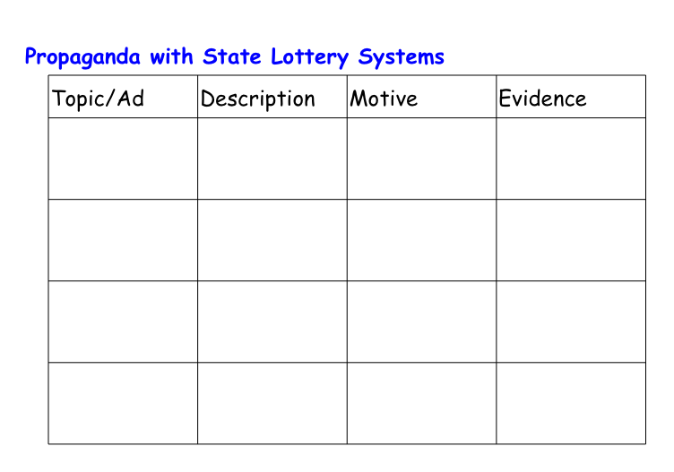

**

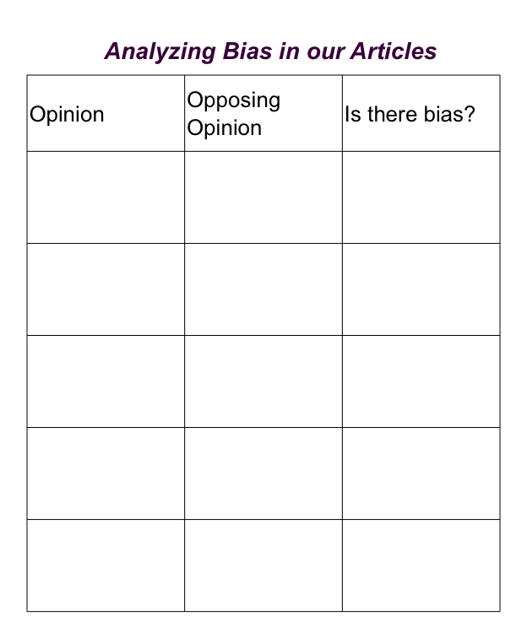

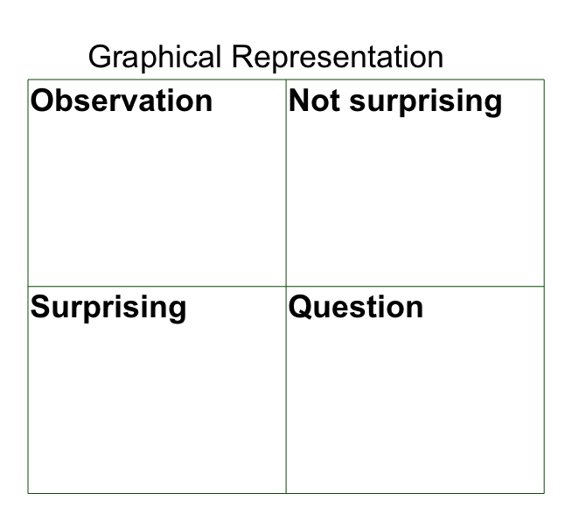

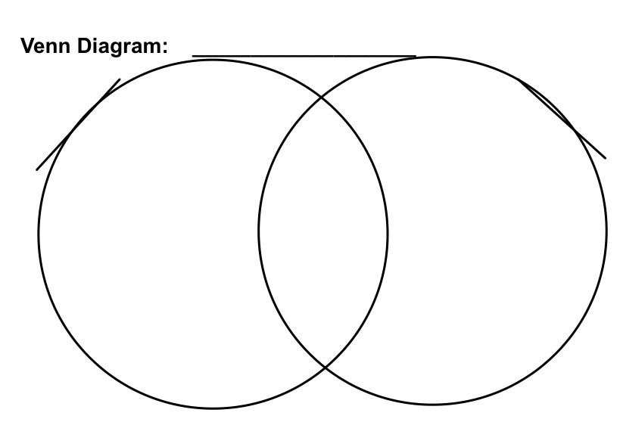

**

**3,2,1 Exit Slip:**

- 3 differences about EACH lottery system

+

+

+

- 2 similarities between both lottery systems

+

+

- 1 opinion about EACH lottery system

+