NEWS:
Naugatuck Resident Claims $2,000,000 in “Big Money”
MoreNEWS
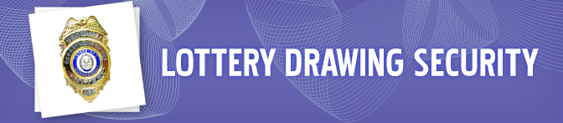
LOTTERY SECURITY
Honesty and integrity is critical to our success. To ensure the public’s trust and confidence, CT Lottery Security Department personnel dedicate themselves to ensure that all who choose to play CT Lottery games have an equal and fair chance of winning. Lottery Security oversees all aspects of security for the corporation including:
  - Routine monitoring of Lottery drawings for compliance with regulatory requirements.
  - Consultations and investigations on reported or suspected incidents involving retailers, consumers, fraudulent activity, public health and safety.

  - Integrity of lottery drawings and scratch game production.
  - Building safety and emergency management.
  - Provides an independent assessment to lottery management and the Board of Directors.

DRAWING METHODS
We have held thousands of lottery drawings since 1972 using reliable and secure methods consistent with industry integrity standards.
People are most familiar with our televised drawings that feature a traditional air-flow machine filled with ping pong balls to randomly select winning numbers. A second method uses Random Number Generator technology. For special promotions (including 2nd Chance Drawings), drawings may be held with a regulated tumbler or Random Number Generator.
No matter which method is used, the highest level of physical and procedural accuracy is assured. In the unlikely event of a problem, emergency procedures are always in place.
TRANSPARENCY
Lottery drawings are held 365 days a year. Most drawings are broadcast "live" on FOX-CT and WCCT-TV to allow the public to see the actual drawing as it occurs. When station conflicts occur, the drawing, customarily, will be conducted "live" and/or played-back on WCCT-TV. Drawings are open to the public, but clearance is required prior to attendance.
DRAWING CERTIFICATION & REGULATORY OVERSIGHT
Lottery drawing staff and Lottery Drawing Officers from the State of Connecticut, Department of Consumer Protection attend all drawings. The Department of Consumer Protection Lottery Drawing Officer inspects the equipment selected for the drawing to ensure its integrity. They observe and record the entire drawing process and certify the drawing to make it "official."
All personnel involved in the production of Lottery drawings undergo and must pass a rigorous background check conducted by the Department of Consumer Protection. If at anytime there is a question as to the character, integrity or suitability of the person involved with the drawing they are immediately removed.
DRAWING STUDIO
The studio where televised drawings are conducted has a "state-of-the-art" physical security system to protect the equipment and related materials involved in the drawing. Studio access is limited to authorized personnel only on an “as-needed” basis.
DRAWING PROCESS
Drawings are conducted according to approved procedures, monitored, and regulated at all times during the drawing process - in the preparation that precedes a drawing, the actual drawing, or completion of post-drawing activities necessary to certify and make the results "official." Steps included in every drawing are:
  - Inspection of equipment that will be used in the drawing
  - Pre-draw “randomization” tests
  - Rehearsal drawings
  - Actual drawing
  - Post-drawing “randomization” tests
  - Post-drawing verification of equipment
  - Entry of winning information into the Computer Gaming System
  - Official drawing certification by the Department of Consumer Protection
  - Report of the drawing results to the public

