|  |  |
| --- | --- |
| **Unit of Study:** State Lotteries **Time:** 1 pd **Date:**  Week of 4/3, Lesson 1  **Essential Question(s):**  Who plays the lottery, why?  **Focus Question:** How do we complete our NYC school survey?  **Language Objective:** SWBAT read and respond to survey questions | |
| **Materials Needed:** student survey cards pencils, pens, chart paper, computers, , laptop (java script & cookies enabled), internet, ipad, projector, elmo, survey cards | **Vocabulary:**  Lottery, Gambling, Chance, Fair, Statistic, Probability, Sample Space,Theoretical/Experimental/Conditional/Independent/Dependent/Compound/Simple/Single Event/Multiple-Event Probability; want/desire; Prediction, Results, Compare, Order, Decide, Analyze, Determine, Conclude, Distinguish, Bias, Targeted Audience, Revenue, Percent, Decimal, Fraction, Funding, Private, Governmental, Successful, Win, Lose/Loss, Prize Structure, Multi-State, Generate, Self-Selected, Computer Generated, Cost, Estimated Gain, Percent Error, Pay Off |
| **Do Now:** Once you get YOUR computer, take a seat. Turn on your computer. Open the web browser. Go to www.nycschoolsurvey.org | |
| **Teach:**  *Today you will be taking a survey. This survey is anonymous and confidential. Still, we need to take it seriously because the school uses your responses to improve. This is a place for you to respond GENERALLY about the school not SPECIFICALLY about one teacher or one instance.* | |
| **Guided Practice:** *If a note appears about enabling cookies or javascript, please allow. When you get on the website, enter your survey access code and password.* | |
| **Independent Practice:** *Student will take surveys while I circulate and offer assistance.* | |
| ***3, 2, 1 Reflection:***  *3- Positive things I was remembering about the school, 2 Questions I have about the school, 1 Thing I think the school could improve on.* | |
| **Post-Lesson Reflection** | |

|  |  |
| --- | --- |
| **Unit of Study:** Locks, Lotto & Lineage **Time:** 1 pd **Date:**  Week of 3/4, Lesson 3  **Essential Question(s):** What is the difference between Experimental and Theoretical Probability? What is the difference between what did happen and what will happen? How do I know I have counted all the possibilities?  **Focus Question:** How do we prepare for the DYO?  **Language Objective:** SWBAT brainstorm words connected to linear equation using a graphic organizer AND SWBAT work through misunderstanding in stations using the question steps. | |
| **Materials Needed:** student notebooks, pencils, pens, chart paper, computers, graph paper, laptop, ipad, projector, elmo, station copies (10/ station), station instructions copies (10 copies total), baskets. | **Vocabulary:** event sample space likelihood  chance random outcome  decision probability ratio same different connection apply sort justify percent  lock password code digit sure certainty repeat |
| **Do Now:** What do you remember about the following words? | |
| **Teach:**  **Stations (5 minutes for each):**  1) Experimental Probability 2) Theoretical Probability  3) Graphing/Describing Data 4) Line of best fit/Correlation/Predictions  5) Calculating Slope/Y-intercept 6) Writing linear equations/Substitution | |
| **Guided Practice:** First, we will discuss ***Station Norms***:   1. Stay in your station for the full time. 2. Do all problems and show all work in your notebook. 3. If confused, use the question steps. 4. Listen for the time to rotate and move quickly to the next station.   We will walk through the 4 stations. Identifying key words, representations and hints. | |
| **Independent Practice:** Students will move between stations (10 minutes each). I will circulate giving assistance and asking higher order questions. *What connections do you see between the station/questions? What questions could be part of this station? What confusion might another student have? How would you help them with that confusion?* | |
| ***3, 2, 1 Reflection: 3 things I learned/remembered today, 2 questions I still have,***  ***1 interesting/important thing someone said today.*** | |

|  |  |
| --- | --- |
| **Unit of Study:** State Lotteries **Time:** 1 pd **Date:**  Week of 4/3, Lesson 2  **Essential Question(s):**  How does the lottery differ from state to state?, Where does the money from the lottery go?, Who owns the lottery?, How likely is it that someone will win? What will they win?  **Focus Question:** How do we investigate state lottery systems and learn key vocabulary?  **Language Objective:** SWBAT describe state lottery systems using academic and content area vocabulary verbally and in writing. | |
| **Materials Needed:** student survey cards pencils, pens, chart paper, computers, internet, laptop, ipad, projector, elmo, chart paper for 4- square model | **Vocabulary:**  Lottery, Gambling, Chance, Fair, Statistic, Probability, Sample Space, Theoretical/Experimental/Conditional/Independent/Dependent/Compound/Simple/Single Event/Multiple-Event Probability; want/desire; Prediction, Results, Compare, Order, Decide, Analyze, Determine, Conclude, Distinguish, Bias, Targeted Audience, Revenue, Percent, Decimal, Fraction, Funding, Private, Governmental, Successful, Win, Lose/Loss, Prize Structure, Multi-State, Generate, Self-Selected, Computer Generated, Cost, Estimated Gain, Percent Error, Pay Off |
| **Do Now:**  Say the following in your own words:  *Check your ticket(s) before leaving the retailer location to verify the numbers and the date printed are correct.* | |
| **Teach:**   **Mini-Lesson: FGs Math Corner** - [www.FGsMathCorner.Weebly.com](http://www.FGsMathCorner.Weebly.com) - State Lottery Project- NY Powerball Page - Choose one other Page- Links to the internet | |
| **Guided Practice:** | |
| **Independent Practice:** Student will conduct on line research on two lottery systems using their graphic organizers and the [www.fgsmathcorner.weebly.com](http://www.fgsmathcorner.weebly.com) website. | |
|  | |
| **Post-Lesson Reflection** | |

*Name: _____________________ Cohort: _____*

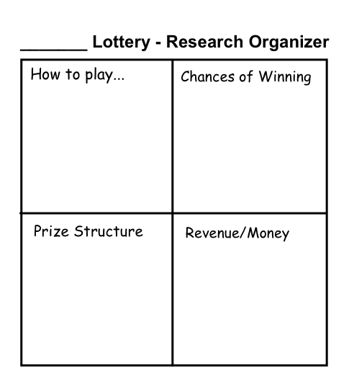

*Name: _____________________ Cohort: _____*

**