|  |  |
| --- | --- |
| **Unit of Study:** State Lotteries **Time:** 1 pd **Date:**  Week of 4/15, Lesson 1  **Essential Question(s):**  Who plays the lottery, why? How does the lottery differ from state to state?  **Focus Question:**  How do we examine the statistics of who plays the lottery?  **Language Objective:** SWBAT read and interpret tables on lottery demographics.  SWBAT develop written questions about lottery demographics.  SWBAT generate relevant sentences about lottery demographic representations. | |
| **Materials Needed:** station boxes with representations, pencils, pens, chart paper, computers, , laptop (java script & cookies enabled), internet, ipad, projector, elmo, colored pencils/markers, group roles, calculators | **Vocabulary:**  Lottery, Gambling, Chance, Fair, Statistic, Probability, Sample Space,Theoretical/Experimental/Conditional/Independent/Dependent/Compound/Simple/Single Event/Multiple-Event Probability; want/desire; Prediction, Results, Compare, Order, Decide, Analyze, Determine, Conclude, Distinguish, Bias, Targeted Audience, Revenue, Percent, Decimal, Fraction, Funding, Private, Governmental, Successful, Win, Lose/Loss, Prize Structure, Multi-State, Generate, Self-Selected, Computer Generated, Cost, Estimated Gain, Percent Error, Pay Off |
| **Do Now:** Make some statements about who plays the lottery.  *Key Words:*  *men women black white hispanic*  *wealthy low-income young old*  *Write 3 generalizations about the lottery:*  *1) ________ people spend the most money on the library.*  *2) People who earn ______ money play the lottery _____.*  *3) Men play the lottery _____ than _____.* | |
| **Teach:** Mini-Lesson: Demographics of the Lottery  **Demographics** are quantifiable statistics of a given population.  *We are going to examine the* ***demographics*** *of the lottery.*  *What groups do you belong to?*  *What kinds of demographics exist in this school?* | |
| Guided Practice: Weird Words  We will look over the 3 graphical representations and identify unknown words. We will clarify or infer the definitions so that they students can interpret the representations.  What words are new to you? What words might you know the meaning? How do you know? How does the context help you?  **Computer Distribution:** (*Make-up kids from last week)*  Once you get YOUR computer, take a seat.  Turn on your computer.  Open the web browser.  Go to ***www.fgsmathcorner.weebly.com*** | |
| **Pair Work: *Potential Questions***  *What questions to do you have about lottery demographics?*  *-*  *-*  *-*  *-*  *-*  **Group Work:**  1) Look over the data piece that you were given.  2) Consider the question your are answering.  3) What statements can you make about the data piece that would help answer the question?  - First, look.  - Second, talk.  - Third, write.  *Be prepared to hand in a paper for each person.* | |
| **Class share:**  ***GROUP SHARE OUT:***  ***Question- Evidence- Decision-***  ***We will work as a class to fill a chart in order to share our findings.*** | |
| **Homework:**  Write a reflection connecting your findings today with one of the previous assignments in this unit:  - 4- square research on lottery systems  - Advertising analysis: motives  - Article Analysis: Bias  - Lottery Representations/Venn Diagram | |
| **Post-Lesson Reflection** | |

|  |  |
| --- | --- |
| **Unit of Study:** State Lotteries **Time:** 1 pd **Date:**  Week of 4/15, Lesson 2  **Essential Question(s):**  How does the lottery differ from state to state?, How likely is it that someone will win? What will they win?  **Focus Question:**  How do we investigate state revenues associated with the lottery?  **Language Objective:** SWBAT sort revenues into self-created categories.  SWBAT use an excel template to construct a pie chart, including labels and a summary.  SWBAT save and email their excel sheet to the teacher thereby demonstrating technological literacy.  SWBAT compare and contrast their pi chart with that of a peer. | |
| **Materials Needed:** student survey cards pencils, pens, chart paper, computers, internet, laptop, ipad, projector, elmo, chart paper for 4- square model | **Vocabulary:**  Lottery, Gambling, Chance, Fair, Statistic, Probability, Sample Space, Theoretical/Experimental/Conditional/Independent/Dependent/Compound/Simple/Single Event/Multiple-Event Probability; want/desire; Prediction, Results, Compare, Order, Decide, Analyze, Determine, Conclude, Distinguish, Bias, Targeted Audience, Revenue, Percent, Decimal, Fraction, Funding, Private, Governmental, Successful, Win, Lose/Loss, Prize Structure, Multi-State, Generate, Self-Selected, Computer Generated, Cost, Estimated Gain, Percent Error, Pay Off |
| **Do Now:** Log-on to engrade and find the assignment:  ***Revenue Excel Sheet.***  Click on the assignment and download the Excel file.  *What do you notice about the excel file?* | |
| **Teach**  Mini-lesson: Categories of Revenue:  What does revenue mean? How does revenue connect to a business? Think of a business and give examples of revenue for that business. What examples of revenue did you come up with in your research of the lottery?  Examine NY Revenue from www.fgsmathcorner.weebly.com  Potential Category Labels: *Student’s think of ways to sort the revenues.* | |
| **Guided Practice: Constructing a Pie Graph**  I will open up the excel template that is available on the weebly website and guide them through a graph for NY. *What do you notice on this template? What will go in each column?*  Including:  **Summary:**  Write 3 sentences about your pie graph.  Key words:  *Most Least Percent (%) Half Quarter*  **Computer Distribution: (*make-up kids – last week)***  Once you get YOUR computer, take a seat.  Turn on your computer.  Open the web browser.  Go to [***www.fgsmathcorner.weebly.com***](http://www.fgsmathcorner.weebly.com) | |
| **Independent Practice: Independent Practice:**  1) Go to the *Revenue* tab on your state lottery.  2) Decide on 2-5 categories and label them on your spreadsheet (***delete unused categories)***.  3) Enter the money under each category.  4) Use the pie chart to write 3 summary sentences.  5) Title your excel sheet, with your name and class.  6) Save your spreadsheet with last name, class. *ie NajeraE13*  7) Send me the spreadsheet via Engrade or email it to [sforbesgray@sunsetparkhighschool.org](mailto:sforbesgray@sunsetparkhighschool.org)  *How will you identify yourself in your email/engrade message? How will you check over your work before submitting it?* | |
| ***Summary: Students will share their pi charts in pairs and discuss similarities and differences.*** | |
| **Homework:** Finish spreadsheet if not finished | |
| **Post-Lesson Reflection** | |

|  |  |
| --- | --- |
| **Unit of Study:** State Lotteries **Time:** 1 pd **Date:**  Week of 4/15, Lesson 3  **Essential Question(s):**  How does the lottery differ from state to state?, How likely is it that someone will win? What will they win?  **Focus Question:** How do we create a lottery system? OR  How do we revise our previous lottery research?  **Language Objective:** SWBAT self-assess their progress on their lottery project.  SWBAT formulate questions for fellow students and the teacher to drive their internet research.  SWBAT offer assistance to peers with regard to internet research  SWBAT develop a lottery game and explain it in complete sentences | |
| **Materials Needed:** student survey cards pencils, pens, chart paper, computers, internet, laptop, ipad, projector, elmo, chart paper for 4- square model | **Vocabulary:**  Lottery, Gambling, Chance, Fair, Statistic, Probability, Sample Space, Theoretical/Experimental/Conditional/Independent/Dependent/Compound/Simple/Single Event/Multiple-Event Probability; want/desire; Prediction, Results, Compare, Order, Decide, Analyze, Determine, Conclude, Distinguish, Bias, Targeted Audience, Revenue, Percent, Decimal, Fraction, Funding, Private, Governmental, Successful, Win, Lose/Loss, Prize Structure, Multi-State, Generate, Self-Selected, Computer Generated, Cost, Estimated Gain, Percent Error, Pay Off |
| **Do Now:** Look over the checklist. Each underlined part =1 point.  1) 4-square research: NY and another state ____(2)  2) Advertisement analysis: NY and another state ____(2)  3) Bias in newspaper articles: NY and another state ____(2)  4) Representation 4-square: NY and another state, ____(4)  Venn diagram and 3,2,1 reflection  **TOTAL = ____ (10)**  ***What is your score? How could you raise your score? How could you support your group in raising their score?*** | |
| **Teach:** *Developing your own lottery system:*  2) For those with a 10/10 (or get to a 10/10 during today's class), you  will be working on developing your own lottery system alone or with a partner who has the same state as you.  **Today's goal:**  1) Develop a game: be specific about possible numbers, number  of possible spaces, and the game's name.  2) Next, you can start thinking about the prize structure and cost of tickets.  *What kind of game will people enjoy playing? Why is your game unique? How will you explain your game to someone else?* | |
| **Guided Practice:**   **Computer Distribution: (*make-up kids- last week’s work)***  Once you get YOUR computer, take a seat.  Turn on your computer.  Open the web browser.  Go to ***www.fgsmathcorner.weebly.com***  ***I will circulate to offer assistance to students who are behind.*** | |
| **Independent Practice:** *Catch-up day!*  1) For anyone with less than a 10/10 on the checklist, you will use  today to catch-up with your research. | |
| **Exit Slip:** *Name: ______________ Class: ______*  1) 4-square research: NY and another state ____(2)  2) Advertisement analysis: NY and another state ____(2)  3) Bias in newspaper articles: NY and another state ____(2)  4) Representation 4-square: NY and another state, ____(4)  Venn diagram and 3,2,1 reflection  **TOTAL = ____ (10)** | |
| **Post-Lesson Reflection** | |

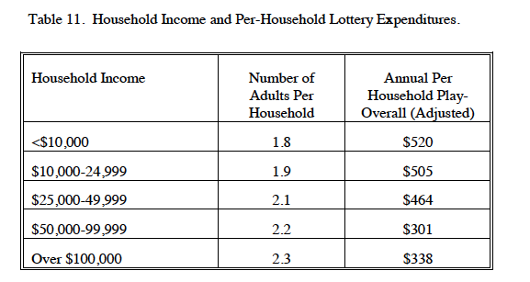

[*http://govinfo.library.unt.edu/ngisc/reports/lotfinal.pdf*](http://govinfo.library.unt.edu/ngisc/reports/lotfinal.pdf)

*Name: ____________________ Class: ____*

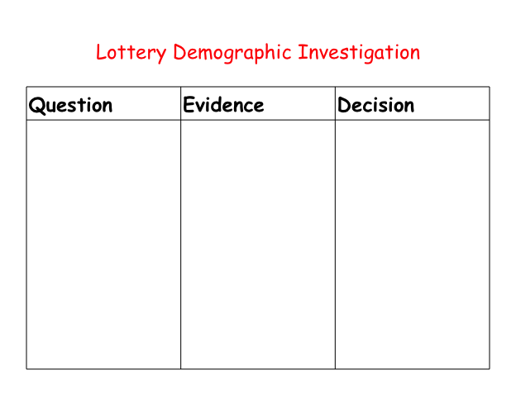

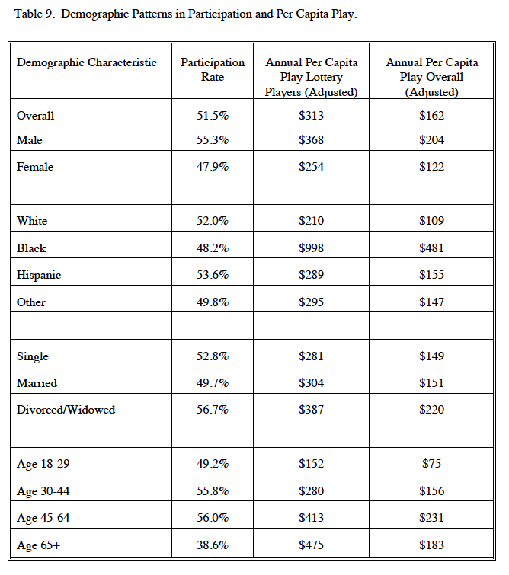

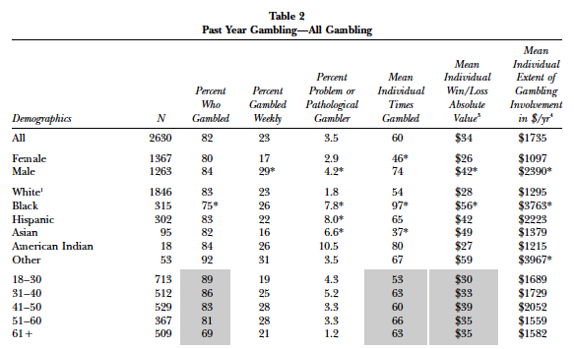

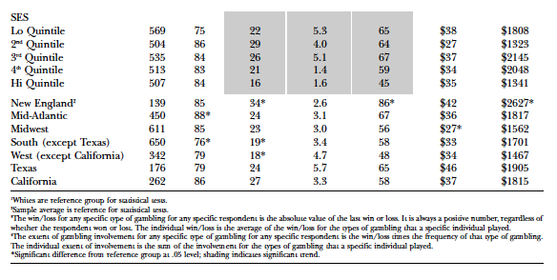

**Exit Slip:** *Name: _____________________ Class: _____*

1) 4-square research: NY and another state ____(2)

2) Advertisement analysis: NY and another state ____(2)

3) Bias in newspaper articles: NY and another state ____(2)

4) Representation 4-square: NY and another state, ____(4)

Venn diagram and 3,2,1 reflection

5) Demographic Analysis ____ (2)

6) Revenue Excel Sheet ____ (3)

**TOTAL = ____ (15)**

**Exit Slip:** *Name: _____________________ Class: _____*

1) 4-square research: NY and another state ____(2)

2) Advertisement analysis: NY and another state ____(2)

3) Bias in newspaper articles: NY and another state ____(2)

4) Representation 4-square: NY and another state, ____(4)

Venn diagram and 3,2,1 reflection

5) Demographic Analysis ____ (2)

6) Revenue Excel Sheet ____ (3)

**TOTAL = ____ (15)**

**Exit Slip:** *Name: _____________________ Class: _____*

1) 4-square research: NY and another state ____(2)

2) Advertisement analysis: NY and another state ____(2)

3) Bias in newspaper articles: NY and another state ____(2)

4) Representation 4-square: NY and another state, ____(4)

Venn diagram and 3,2,1 reflection

5) Demographic Analysis ____ (2)

6) Revenue Excel Sheet ____ (3)

**TOTAL = ____ (15)**

**Exit Slip:** *Name: _____________________ Class: _____*

1) 4-square research: NY and another state ____(2)

2) Advertisement analysis: NY and another state ____(2)

3) Bias in newspaper articles: NY and another state ____(2)

4) Representation 4-square: NY and another state, ____(4)

Venn diagram and 3,2,1 reflection

5) Demographic Analysis ____ (2)

6) Revenue Excel Sheet ____ (3)

**TOTAL = ____ (15)**